


Bradford Cederberg, PA


INITIAL TREATMENT:

An injured person MUST receive some type of medical care within 14 days of their accident or there is NO PIP coverage available.
They can go anywhere for initial treatment.
- Hospital
- Ambulatory Care Center
- MD/DO and even Chiropractor
- Ambulance/EMTs


FOLLOW UP SERVICES AND CARE
IF you are referred from your initial provider AND your treatment is “consistent with the underlying medical diagnosis rendered” you can obtain follow up care.

Hospitals and ambulatory surgery centers can provide follow up care, as can PAs and ARNPs and PTs can if the referral is made by an MD or DO.

Expect a lot of denial of charges (and resulting litigation if you wish to be paid) asserting that follow up care is not consistent with the underlying medical diagnosis and/or the follow up care was not based on a referral from initial treating health care provider.




 $10,000 if there is an EMC
$2500 if there is not an EMC

 EMC is no longer just an Emergency Department issue. It has now become a PIP issue that will affect not only hospitals, but:

Radiologists Neurosurgeons
Orthopedic Surgeons Neurologists
Family Practitioners Pain Management
I’ve Been in an Accident and Need Medical Care.

What Do I Do?

Did the accident occur more than 14 days ago?

Yes No

Have you had any accident related medical treatment rendered by: EMT, ambulance, or ER, or been seen by an MD/DO/Dentist/Chiropractor?
You need to be seen by an MD/DO/Dentist/Chiropractor and/or seek treatment at a hospital or a facility owned by a hospital within 14 days to preserve your PIP benefits.

No Yes

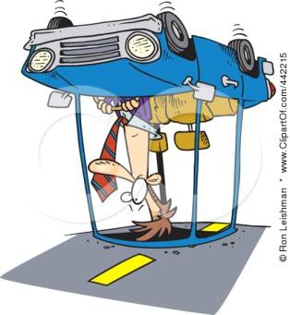

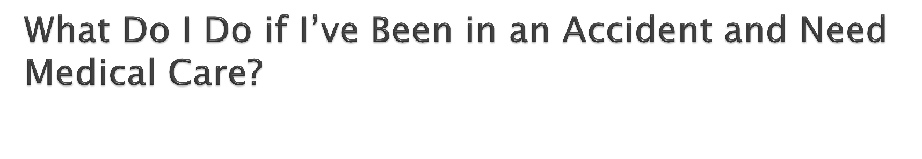
There is no PIP coverage available to you.

You may receive follow-up care:
- Consistent with the underlying medical diagnosis
- Based on a referral from an initial care provider:
  - an MD/DO/Dentist/Chiropractor or their PA/ARNP
  - a PT if referred by an MD/DO/Dentist/Chiropractor
  - a hospital or a facility owned by a hospital
  - a certified health care clinic



 The PIP statute allows the determination of an EMC to be made after the fact – the wording in the statute is ‘had’, not ‘has’.

 Expect rampant challenges to EMC – it is the difference between an insurer paying out
$2500.00 vs. $10,000.00 in benefits.






$2,500

$10,000

EMC


“Emergency medical condition” means a medical condition manifesting itself by acute symptoms of sufficient severity, which may include severe pain, such that the absence of immediate medical attention could reasonably be expected to result in any of the following:
    - (a) Serious jeopardy to patient health.
    - (b) Serious impairment to bodily functions.
    - (c) Serious dysfunction of any bodily organ
or part.


 There are NO benefits for massage therapy or acupuncture.

 It does not matter what entity or licensed provider is rendering the service. Massage and acupuncture will not be reimbursed to an LMT, licensed acupuncturist or any other type of provider rendering those services.

 Keep this in mind if your physicians employ
massage therapists or acupuncturists



 200% of Medicare Part A (x 80%) for outpatient and non-emergency inpatient care

 75% of Usual and Customary (x 80%) for Emergency Services and Care provided by the Hospital

 Usual and Customary charge (x80%) for providers of emergency services and care (MD’s/DO’s/Emergency Department physicians trauma physicians/orthopedic surgeons/radiologists)


 Reimbursement is never to be lower than the 2007 Medicare rates. If it is, use the 2007 rates.

 Use the Participating Provider rates, as of March 1of the calendar year in which services were rendered to determine reimbursement for the remainder of that year.

 Use Medicare Part B for services and supplies

 Use DME Medicare Part B for Durable Medical
Equipment


“Permissive” policy language litigation

- The Carrier must endorse their policy PROPERLY in order to use the fee schedules

- Carriers attempted to use the fee schedules when they had not endorsed their policies to allow for it, or endorsed them incorrectly

 Kingsway Amigo vs. Ocean Health, Inc. (Fla. 4th
DCA 2011)

 Carrier was not permitted to pay at the (lower) fee schedule rate when their policy did not have an endorsement electing payment in this fashion.

 Court determined there were two methods of reimbursement – fee schedule and usual and customary and failure to specifically elect fee schedule required them to pay at usual and customary.



 GEICO Indemnity vs. Virtual Imaging
Services, Inc. (Fla 3rd DCA 2011)

 Carrier who did not endorse, have not properly endorsed include:
State Farm, GEICO, Progressive, etc.

 NCCI Edits and OPPS reductions are now permitted “if it doesn’t constitute a utilization limit.”



 OPPS: Outpatient Payment Perspective
System– A creation of CMS

 Carriers attempted to use OPPS as a method of reducing fee schedule payments

 Nationwide Mutual Fire Ins Co. VS AFO
Imaging (FLA 2nd DCA 2012)


 NCCI Edits: National Correct Coding Initiative
developed by CMS

 Carriers attempted to further reduce fee schedule payments to providers by refusing to pay for a second service rendered on the same day

 SOCC PL d/b/a South Orange Wellness vs.
State Farm (Fla. 5th DCA 2012)



 Must a carrier specifically include a policy endorsement in order to use the lower reimbursement amount (fee schedule) set forth in the PIP statute?

 The answer intended by the legislature when they amended 627.7311 is “no”; however, the applicable section of 627.736 directly conflicts with this.
 This issue will only be resolved through PIP
litigation.

 This is intended for providers of emergency
services and care and inpatient hospital
treatment rendered by MDs/DOs/Dentists.
This does not include hospitals.

 If an emergency service provider submits claims within 30 days of notification of a covered loss, those providers should be paid before the Hospital bill can exhaust the PIP benefits.
 Hospitals often receive PIP limits even when
emergency service providers submit their bills
in within the 30 day window. This is improper.

 Providers of emergency services and care have priority to $5,000 of the $10,000 in PIP benefits only if their bill is received within 30 days of the date the carrier learns of the accident.

 If fraud is suspected, the carrier must notify the
provider in writing within 30 days of the receipt of
the claim that it is being investigated for suspected
fraud.
 If notification is made, it extends the time to
conduct the fraud investigation.

 The claim must be denied or paid with interest within 90 days of submission.

 The suspected fraud must be reported to the Department of Insurance Fraud.

 Examinations Under Oath (EUO) are now a condition precedent to receiving PIP benefits.

 Custer Medical Center vs. United (Fla 3rd DCA 2010)

 If an injured patient does not attend an EUO, none of the medical providers have a right to payment until the patient sits for the Examination Under Oath.

 A health care provider is not required to attend an EUO.

 The questions in an EUO are limited to relevant information including accident details, coverage eligibility, or claimant information, or information that could be reasonably expected to lead to relevant information.



